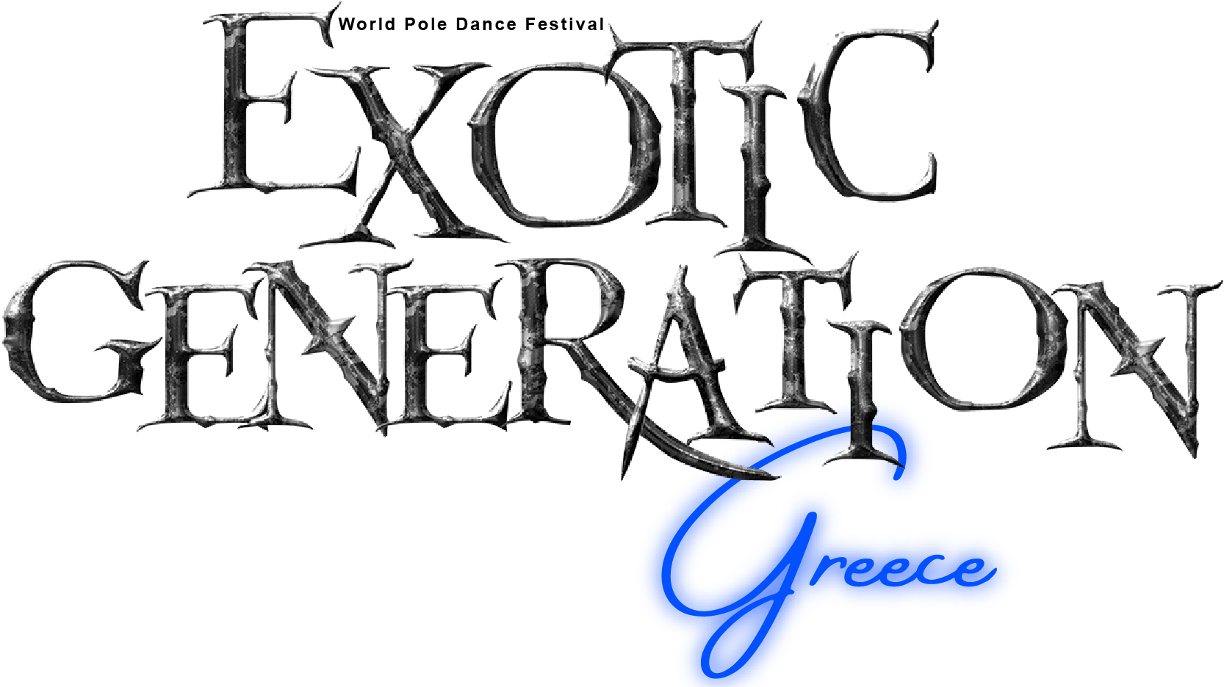
APPLICATION FORM ‘25
PERSONAL INFORMATION
STAGE NAME
FIRST AND LAST NAME
EMAIL
INSTAGRAM
FACEBOOK
DATE OF BIRTH
COUNTRY
CATEGORY
OTHER PARTICIPANT’S NAMES
(IN CASE OF A DUET - OR A GROUP)
POLE DANCE BACKGROUND
EXOTIC EXPERIENCE
POLE – WORK EXPERIENCE
I’VE PARTICIPATED IN EVENTS SUCH AS
I HAVE WON POLE DANCE TITLES
IF YES
MEDIA
VIDEO LINK(S)
WAIVER OF LIABILITY:
I DECLARE THAT ME AND MY TEAM HAVE READ, UNDERSTOOD, AND AGREED TO EXOTIC GENERATION GREECE RULES AND REGULATIONS, BOTH IN THE WORKPLAN AND COMPETITION’S OFFICIAL WEBSITE. FAILING TO COMPLY WITH THE ABOVE MAY OCCUR TO DISCIPLINARY ACTIONS.
I ALSO ACKNOWLEDGE THAT POLE DANCE IS AN EXTREME SPORT AND I AM PARTICIPATING IN THIS FESTIVAL AT MY OWN RISK. I AGREE THAT EXOTIC GENERATION GREECE AND ITS AFFILIATES CANNOT ACCEPT THE RESPONSIBILITY OR LIABILITY FOR ANY INJURIES, DAMAGE OR LOSS SUSTAINED DURING THIS FESTIVAL. I THEREFORE AM RESPONSIBLE FOR MY OWN SAFETY AND INJURIES, DAMAGE OR LOSS SUSTAINED DURING THIS FESTIVAL.
BY SIGNING I DECLARE THAT I HAVE READ, UNDERSTOOD, AND AGREE TO BE BOUND BY THE TERMS AND CONDITIONS DESCRIBED ABOVE.
MY SIGNATURE ALSO GIVES EXOTIC GENERATION GREECE PERMISSION TO USE MY PHOTOS/VIDEOS FOR PROMOTIONAL AND/OR PUBLICATION MARKETING.
I HAVE READ THE RULES AND REGULATIONS AND I AGREE WITH THEM |  |  |  | YES 
SIGNATURE |  |  | DATE

*All fields are required.

